Board of Directors
Chair Dr. Rolf Ahlers
Tim Bechard
Sarah Brown
Kathryn Hull
Arlene Lotters
Shirley Mockel
Mary Helen O’Keeffe
Robert Tully
Executive Directors
Dr. Lorraine Ruffing and
Dr. Carol Collins
Sec/Treasurer Beverly Pozzi
Outreach Lisa Adamson

John Apperson, A Man for all Seasons
The annual meeting of the APWQC invited Laura Lee, registered historian, archivist and curator, to speak about the many contributions of John Apperson to the preservation of Lake George. Not much was known about Apperson’s contribution to our current Lake quality until his niece, Ellen Apperson Brown, published her book, John Apperson’s Lake George. In 1908 Apperson led the effort to promote the islands for recreation and he became concerned about the damage he had seen. The major source of island erosion was the operation of the dam at Ticonderoga which allowed the International Paper Company to flood the islands and shores effectively using the Lake as if it were a mill pond. Apperson enlisted his friends to move rocks and construct rock walls around the shores. These work crews used barges in summer and horse-drawn sleds in winter to protect the islands. By 1917 Apperson’s advocacy obtained $10,000 from Albany to hire steamboat crews to continue to rip-rap the islands.
Apperson sought legal advice to prevent IPC from damaging the islands, docks and shoreline. In 1942 Apperson and friends brought a lawsuit against IPC which dragged on for 12 years. It established that the State of New York was responsible for regulating water levels at Lake George and not the paper mills. However, there were personal repercussions for Apperson who was an employee of GE. IPC urged GE to fire Apperson. His job was saved only by the intervention of GE’s Nobel Prize winner, Irving Langmuir, who threatened to quit if Apperson were fired. Apperson was successful in getting the state to buy the central section of Lake George and to prevent the reckless logging practices of IPC and others. Apperson was a major influence in upholding the forever wild clause. He secured the permanent protection of Dome Island and he prevented Robert Moses from building a road on the shore of Tongue Mt. One can easily imagine how very different Lake George would look today if Apperson had not kept up the pressure against all those motivated by greed and self-interest.
Short Note
The Annual meeting was held on 1 Sept; Rolf Ahlers was elected as Chair of the Board and Tim Bechard was elected to the board. Thank you to Mary Helen O'Keeffe for her service during 2016-17 as Chair of the Board.
The Assembly Point Water Quality Coalition, Inc. is a 501c3 non-profit corporation committed to improving and restoring water quality and compromised ecosystems in the Lake George Lake Champlain Basin by supporting policies, regulations and practices which preserve and protect waters and watersheds.
Wooly Adelgid Beetle Spotted on Prospect Mountain
The NYS Department of Environmental Conservation (DEC) announced a minor infestation of the Hemlock Woolly Adelgid on Prospect Mountain. This is the first known infestation of Hemlock Woolly Adelgid (HWA) in the Adirondacks. HWA infestations can be most noticeably detected by the small, white, woolly masses produced by the insects that are attached to the underside of the twig, near the base of the needles.
Previously, this invasive, exotic pest has been detected in 29 other counties in New York, primarily in the lower Hudson Valley and in the Finger Lakes region. HWA, a tiny insect from East Asia first discovered in New York in 1985, attacks forest and ornamental hemlock trees. Hemlock decline and mortality typically occur within 4 to 10 years of infestation in the insect's northern range.
Damage from the insect has led to widespread hemlock mortality throughout the Appalachian Mountains and the southern Catskill Mountains with considerable ecological damage, as well as economic and aesthetic losses.
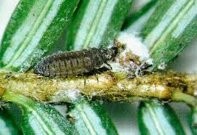
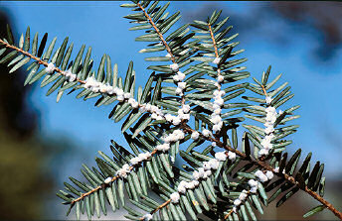

APWQC
66 Bay Parkway
Lake George, NY 12845

Please consider a tax exempt donation to the APWQC.
Beverly Pozzi 656-9440, apwqc7@gmail.com

