July 25, 2015 APWQC Second annual snorkel swim

The Assembly Point Water Quality Coalition held a second snorkel swim. Kathy Bozony, Environmental Program Manager, Town of Lake George and diver and algae specialist, and Lisa Adamson did four 45min-1hour snorkel swims along Assembly Point close in to docks and shorelines; APWQCoalition members participated by kayaking (Dedee Connor and Mary Helen O’Keeffe)or (snorkeling David Taylor). Rolf and Luise Ahlers, provided a pizza party lunch break on their dock and attended the afternoon talk back, wine and cheese party hosted by Mary Helen. Laraine and Tony Metivier let us to use their dock and talked with us about what we were seeing, underwater. Tony had snorkelted the week before around his property. Tami Carstensen joined Kathy for discussion on new ETU septic possibilities. Kathryn Hull, Shirley Mockel, who drove all the way up from Albany to support the effort, Bob Tully, and Tara O’Keeffe all gave support. The snorklers, covered:
- Harris Bay from Connors around to the Happy Family Islands,
- Assembly Point West side from 154 Lake Parkway to the Ahlers property just above the DeSormo Bay and
- the east side from the Metivier dock up to the Phil Morse property ( done in 2 shifts).

.
In 2015, the most obvious sitingss of algae were in Harris bay to the east of Cannanuci’s property. All photos from this swim are from that area.
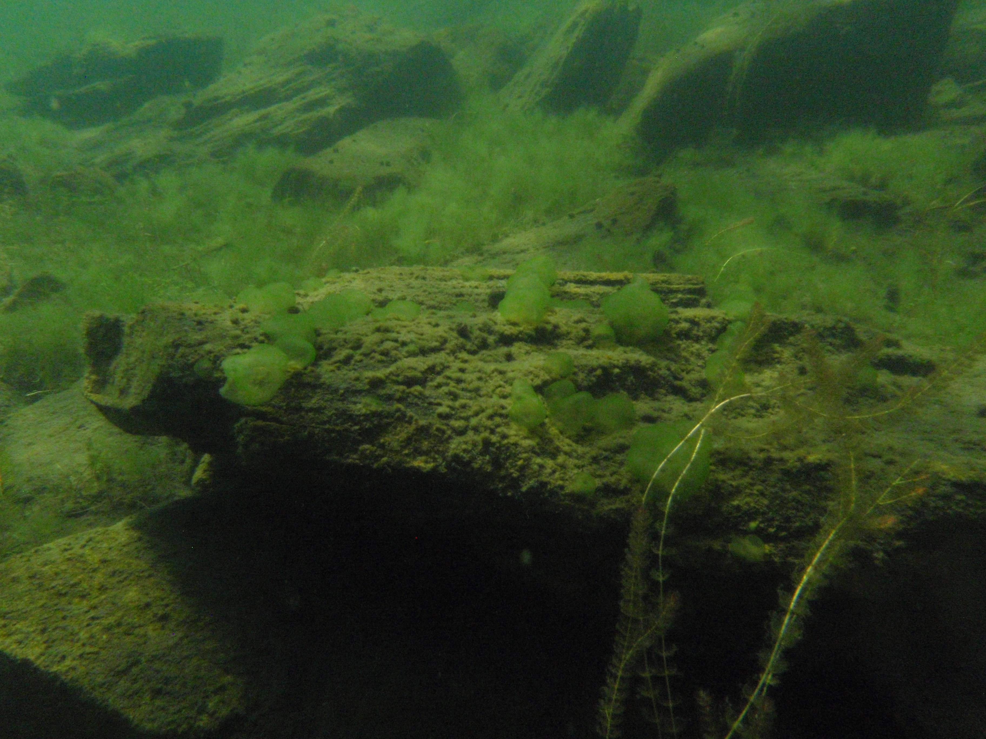
There was also some milfoil.
Rocks in that area had surface deposits of former algae.
BobTully and Kathryn Hull helped us launch the second swim off of the Taylor’s dock at 11:30. We saw algal growth on the south side of Taylor dock similar to picture below and continued to see much of the same condition down as far as Hearsts. although certain areas seemed clearer

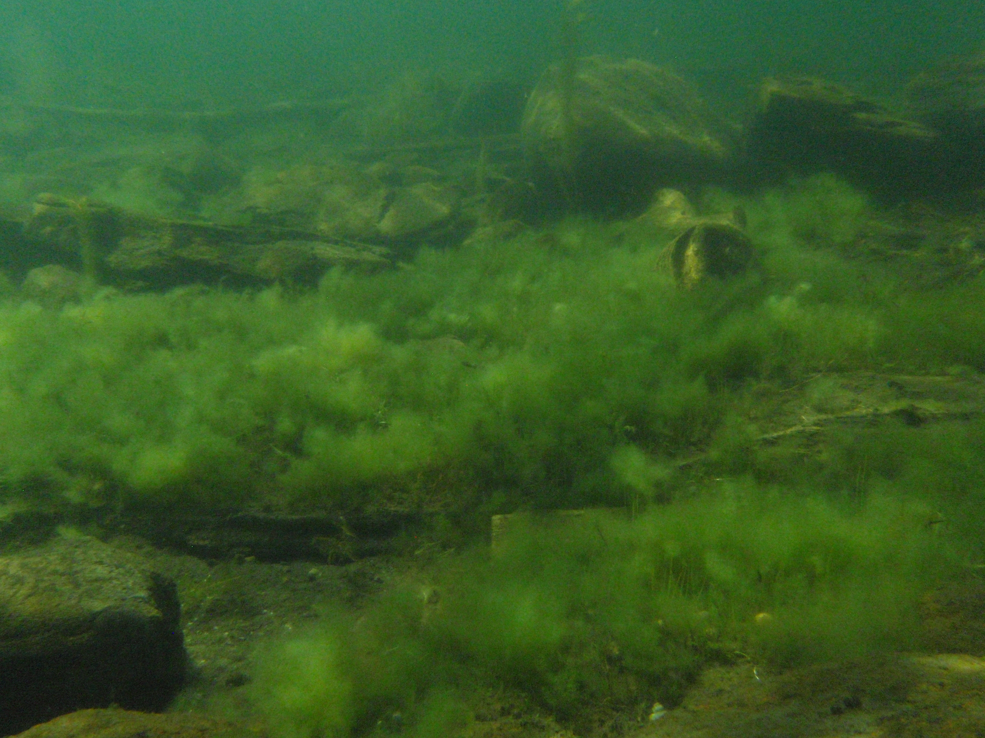
From Hearst’s to Ahlers the bottom gets clear.. Ends of docks in the Taylor to Hearst stretech had accumulated old algae in clumps, small “poo balls.

Lastly we swam off of Metiviers up to Provenzano’s. Laraine and Tony’s dock area on north side was clear but about 25 feet north was a patch which looks like the above photo about 10 square feet off the Brock’s boat dock. The rocks in general along this route were coated with old algae; at the Caffry house and one north there were patches of algae in amongst rocks.
On 7/23 we snorkled in the Ruffing Pozzi Bay with Lorraine R. There was dense growth of low algae off Lynches to north similar to above photo; along shoreline up to Morse’s there was algae off each property in low growth patches between leaves and small rocks. The bay right off of Lorraine’s dock was clearer than last summer, but off the Otyokwa stream outlet there was a lot of algae and up to the bay point was significant growth along shorelines and docks.

In 2014 residents who had not seen the algae along their shorelines snorkeled with Kathy and learned to identify algae, aquatic plants and milfoil. APWQC then took algae samples and found various levels of pollution, some organic.. No samples were taken on the July 25, 2015 swim, but we anticipate snorkeling later this season and taking samples. Corrina Paranpy who has left the Fund has established her own consulting business at http://parnapyc.wix.com/avacal-biological and will charge any lake George person $10 per sample.
If anyone wants to know what they can do about water quality, APWQC suggests first just to get in the water around their own docks with a mask and see what they see. Then send us observations at apwqc7@gmail.com or call in with questions.
Kathy Bozony will be doing snorkel swims in Hague this summer and off Pilot Knob. We are hoping to establish a lakewide network of “snorkelkeepers” who will be trained volunteers swimming seasonally to observe chaning conditions along their own neighborhood shorelines.
Call Lisa Adamson 307 7842 for further information.

