D

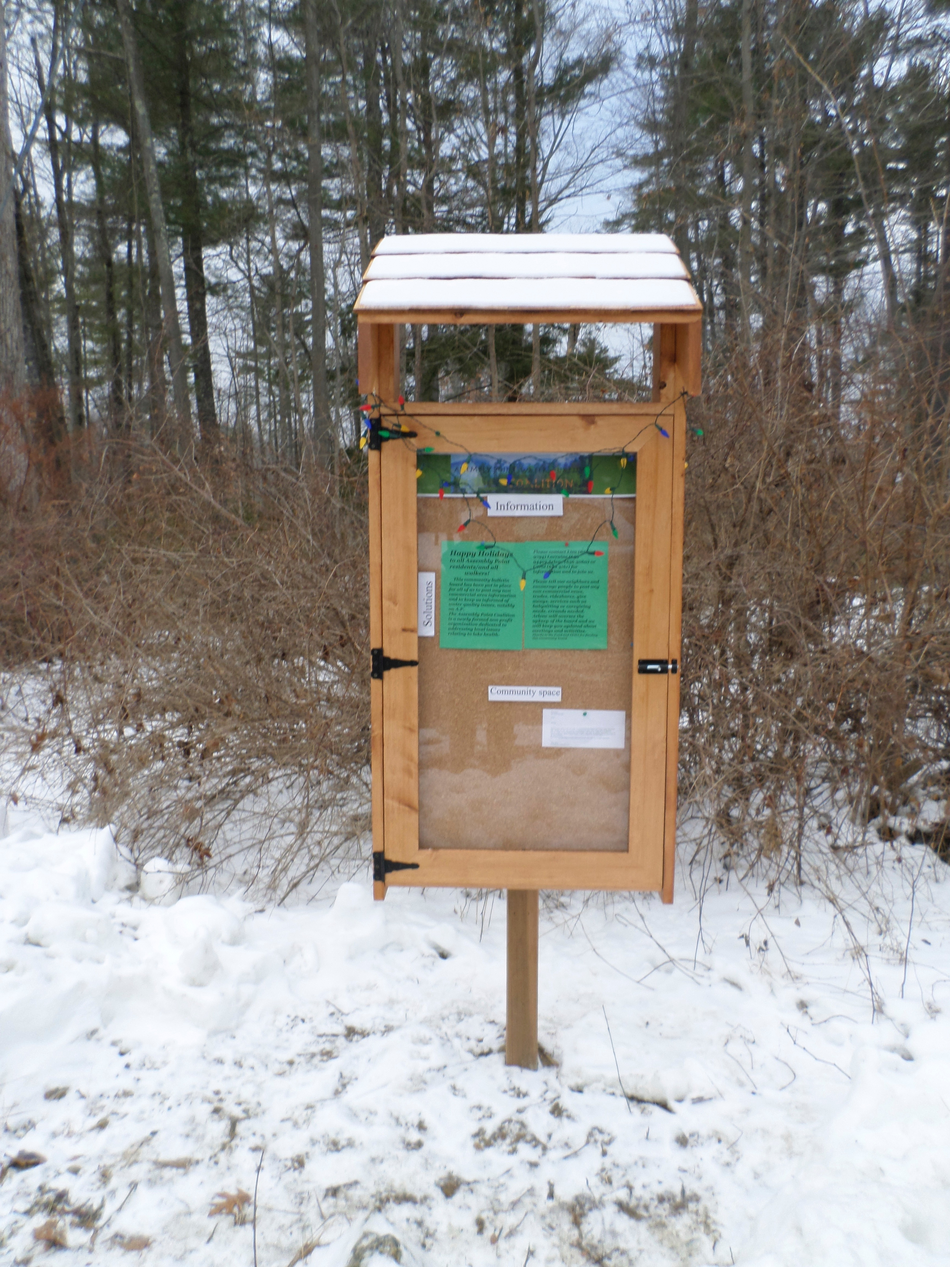

“This effort will seek to develop an important road map for the protection of water quality and resource conservation critical to the future of Lake George.” Queensbury Supervisor John Strough

* Save the date**:** APWQC Annual Meeting, August 26 at 66 Bay Parkway.
* Many thanks to the Lake Champlain Basin Program for a $4000 APWQC organizational grant.
* Save the date: Ass**e**mbly Point Snorkel Swim: July 16. Learn more about algae and aquatic plants
* APWQC has funds available to assist in planting buffers, rain gardens, and for installing swales and diverters for driveway remediation. [apwqc7@gmail.com](mailto:apwqc@gmail.com)

**Co-Executive Directors**

Dr. Lorraine Ruffing and

Dr. Carol Collins

**Sec/Treasurer** Beverly Pozzi

**Board of Directors**

Lisa Adamson, Chair

Dr. Rolf Ahlers

Sarah Brown

Shirley Mockel

Kathryn Hull

Arlene Lotters

Mary Helen O’Keeffe

Robert Tully

**A New Watershed Management Plan for Lake George**

The Lake George Watershed Coalition is about to undertake the development of a new Watershed Management Plan for Lake George that will guide future actions to protect water quality and resource conservation. The Coalition is a group of 25 local governments, state agencies and non-governmental organizations that was formed in 2001 to advance initiatives to protect and preserve Lake George water quality and natural resources. Watershed protection is critically important to the economic and environmental health of the region.

In 1987, the Task Force for the Future of the Lake George Park prepared “The Plan for the Future of Lake George Park” to develop strategies and actions to improve the water quality and natural resources of the Lake George Watershed. The 1987 Plan identified point and nonpoint source pollution as the greatest threats to Lake George (wastewater, stormwater runoff and erosion from development) and provided over 200 recommendations to address this and other issues.

Unfortunately, a significant number of the 1987 Plan’s recommendations were never implemented. Evidence of this is the fact that, since that time, at least seven of the eleven water quality markers identified have failed to meet the recommended standards. This signals that watershed management has been compromised and water quality has degraded. In fact, subsequent Coalition reports in 2006 and 2014 found that water quality continued to worsen due to lack of action to resolve these issues.

As a result, the Coalition decided to develop a new plan. Effective implementation of recommendations, old and new, is the Coalition’s primary goal. The new plan will include a watershed vision statement, public participation plan, inventory and analysis of watershed assets and conditions, assessment of existing local laws and programs which protect the Lake, recommendations for restoration and protection of water quality; and an implementation strategy.

The Coalition should seek to address the most urgent needs of the Lake: reduce runoff and protect groundwater quality; protect and restore wetlands; protect public health and drinking water supply; develop and implement anti-degradation policies; identify and protect high-quality natural features of forested area and riparian corridors; reduce sediment discharges and nutrient input to Lake George; and coordinate educational efforts.

As Lake George Village Mayor Robert Blais explained, “the benefits to such an undertaking are several, including: giving community leaders a voice in protecting and restoring watershed resources, focus our limited resources on activities and programs to address challenges to the lake that need greater protection, and establishment of a baseline for measuring the success of our management efforts.”

Please consider a tax exempt donation to the APWQC this year!

Would you like to receive this via email?

Contact: Beverly Pozzi 656-9440; [apwqc7@gmail.com](mailto:apwqc@gmail.com)

**Alternatives to Sealcoating**

In our article “Toxins and Water Quality” (Summer 2015, Newsletter 3), we described sealcoating’s negative effects on the quality of our lake water. Among other things, it accelerates storm water runoff and deposits toxins in the Lake. Residents of the Point wishing to improve their properties and save the Lake have a number of alternatives.

In considering the various alternatives, a first step may be to reduce the overall size of the driveway whenever possible. The cheapest and easiest alternative is the use of crushed stone in the place of the coal-tar based surfaces. Crushed stone does require some care when using a snow blower.

A second alternative is permeable pavement that is a hard surface that allows rainfall to percolate to underlying soils. Permeable pavement includes: individual unit paving blocks; plastic or fibrous grid systems filled with sand, gravel or living plants; and specialty mixes of both concrete and asphalt which have large pores or open interconnected spaces permitting infiltration. Unit pavers consist of interlocking paving blocks separated by narrow gaps that are filled with sand or gravel. They are appropriate for low traffic volume areas such as private driveways.

Permeable pavement may not be appropriate when the land exceeds a 20% slope. In this case, it is necessary to combine the pavers with buffers, swales or diverters so that drainage from the land is largely captured before it reaches the permeable surfaces. It is important to engage a reputable company to ensure that the design takes into account such considerations as slope. Permeable pavement can be used in very cold climates provided it is designed to prevent frost heave.

The cost of permeable pavement may exceed that of other alternatives but will decrease the cost of the continuous deterioration of water quality and the consequent impact on property values. Additional information on permeable pavement can be found on our website [www.assemblypt.com](http://www.assemblypt.com).

APWQC

66 Bay Parkway

Lake George, NY 12845

**The Assembly Point Water Quality Coalition, Inc. is a 501c3 non profit corporation committed to improving and restoring water quality and compromised ecosystems in the Lake George Lake Champlain Basin by supporting policies, regulations and practices which preserve and protect waters and watersheds.**