Japanese knotweed – Fallopia japonica
Background Information
Japanese knotweed is a highly invasive perennial that is native to East Asia in Japan, Korea and China. It is shrub like in appearance and can grow to heights of 12 feet or more. Its canes are similar in appearance to bamboo, and are typically light green with deep-purple blotches. Canes are hollow and smooth and have raised ridges where the leaves meet the stem. The leaves are broad and oval with a finely pointed tip and blunt base. They range in size significantly with the size of the plant and may exceed 12” in length. Japanese knotweed produces large clusters of greenish-white flowers in late summer, but it does not produce a significant quantity of viable seeds when growing in the northeast. Japanese knotweeds primary spread mechanism is fragmentation of the root system and vegetation.
Spread
Japanese knotweed is spread readily by human activity. The canes and rhizome system are capable of producing rootlets when broken apart. Each individual fragment of plant material can settle to the ground and form a new infestation. Japanese knotweed is primarily spread by mowing along the roadsides and through the movement of contaminated fill. When growing along riparian corridors or other water bodies, Japanese knotweed can be broken apart and spread by high water events such as flooding. Japanese knotweed can grow 3-4 meters in just 10 weeks.
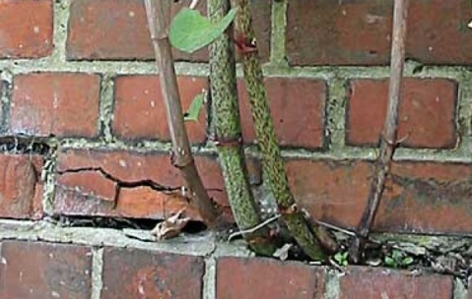
Problems
Photo 1. Japanese knotweed penetrates a brick wall.
- Infrastructure The rhizome system of Japanese knotweed is incredibly tenacious and is capable of penetrating hard substrates. Japanese knotweed commonly grows through roads, home foundations, and concrete sidewalks. The cost of Japanese knotweed invasions in the United Kingdom is estimated to be over $10 million per year.

- Ecological

  - Japanese knotweed spreads quickly to form dense thickets that exclude native species and are of little value to wildlife (Holzner, 1982).
  - Knotweed leaf and stem detritus might affect the food base for trout and other stream fishes (Sweeny, 1993).
  - Reduces Nitrogen input into streams, reduces abundance of understory herbs, shrubs, and juvenile tress (Urgenson and Reichard, 2007).

- Flooding/Sedimentation Stands of Japanese knotweed grow so densely that their understory is often completely devoid of any other vegetation. The thick canopy blocks sunlight from reaching the soil surface and prevents the growth of groundcover species. As a result, areas beneath stands of Japanese knotweed often contain bare soil that is prone to runoff during heavy rain event. When growing along a water body, this can result in sedimentation that is harmful to aquatic invertebrates and fish and degrades fish spawning areas.
- Viewshed Issues When Japanese knotweed grows along the roadway it can block road signs and create blind spots that are a hazard to motorists.
Potential Solutions
In-situ herbicide treatment Japanese knotweed can be treated onsite using selective application techniques that target the invasive plants and maintain the integrity of surrounding native vegetation and the environment. This treatment technique would utilize stem injection, foliar spray, or a combination of both techniques to apply a glyphosate based herbicide to the knotweed. A 90%+ reduction in plant abundance is typically observed following the first year of treatment.
Matting This technique involves manually hand harvesting the knotweed canes and covering the ground with an impermeable membrane to prevent sunlight from reaching the soil surface. Since the plant has incredibly aggressive roots that can grow up to 50 feet from the heart of the infestation, a significant buffer distance must also be matted to prevent re-sprouting. Mats must be carefully maintained for excess of 5-10 years to achieve effective control. This solution is likely not a viable option for the infestations on assembly point.
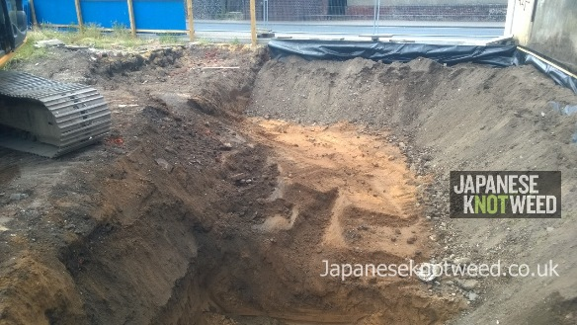
Excavation The entire Japanese knotweed infestation can be excavated and moved off site. This technique is extremely resource intensive and is not sustainable on a large scale. Typically the rhizome material will be contained within the top 0.5 meters of soil. Excavation can be complicated by the presence of buried electric/gas lines and native roots. By undertaking large scale excavation, you risk damaging the roots and injuring otherwise healthy plants in the immediate vicinity. After removing the knotweed contaminated soil, clean fill must be brought into the site to bring the area up to grade. The area will have to be closely monitored for several seasons to detect any re-sprouts. After one season of intensive excavation, re-spouts could feasibly be removed by hand.
Photo 2. A Japanese knotweed infested area being managed by excavation.
It is imperative that the contaminated fill be handled and disposed of with extreme caution. In the United Kingdom, Japanese knotweed contaminated fill is classified as a hazardous waste. There are a few options for disposing of Japanese knotweed contaminated fill off site:
Burial Japanese knotweed contaminated fill can be disposed of by burial in a pit at least 5meteres deep. The contaminated will is deposited in the pit, covered with a root barrier, and then covered with clean fill. This must be conducted in an area that can be closely monitored for several seasons to detect any re-emergence. It is advised that the disposal area is a location where herbicide use is permitted to treat any potential re-sprouts.
Bund and Treat Japanese knotweed contaminated fill can be moved to a secondary location where it is contained within a bund. A bund is a shallow area of Japanese knotweed-contaminated soil, typically 0.5m deep. The bund can either be raised, on top of the ground, or placed within an excavation to make the surface flush with the surrounding area. The purpose of the bund is to move the Japanese knotweed to an area of the site that is not used. This 'buys time' for treatment that would not be possible where the Japanese knotweed was originally located. The bund is typically encased with a root barrier membrane that prevents the plant material from escaping. The area must be closely monitored for the inevitable growth of knotweed, which is then treated with chemical techniques. This is a long term commitment that involves monitoring the site for at least five years.
Incineration Knotweed contaminated fill can also be disposed of in an approved incineration facility. **Note: I’m not sure if this method would be approved for use in New York.

Take Away Points
- All management techniques are long term commitments. You should be prepared to dedicate at least 5 years for treatment. Mechanical control techniques may need to continue in perpetuity.
- When there are several infestations located in close proximity to one another, all sites must be managed to prevent one from serving as a source population.
- Mowing of knotweed should be discouraged when possible and can help reduce further spread.
- Planting of native vegetation is unlikely to suppress or contain the advancement of Japanese knotweed

