Coalition Receives a Grant to Monitor Algal Blooms
Board of Directors
Chair Dr. Rolf Ahlers
Tim Bechard
Sarah Brown
Kathryn Hull
Arlene Lotters
Shirley Mockel
Mary Helen O’Keeffe
Robert Tully
Executive Directors
Dr. Lorraine Ruffing and
Dr. Carol Collins
Sec/Treasurer Beverly Pozzi
Outreach Lisa Adamson

The Lake Champlain Basin Program has awarded the Assembly Point Water Quality Coalition a Pollution Prevention and Habitat Conservation Grant to monitor water quality along the shores of Assembly Point. Under the grant the Coalition will select 20 to 30 sites to monitor algal blooms along the shoreline. This will be done during the months of July and August during our annual snorkel swims. Residents are invited and encouraged to participate in the swims, and to contact Lisa Adamson (518-307-7842) if they think a particular site should be monitored.
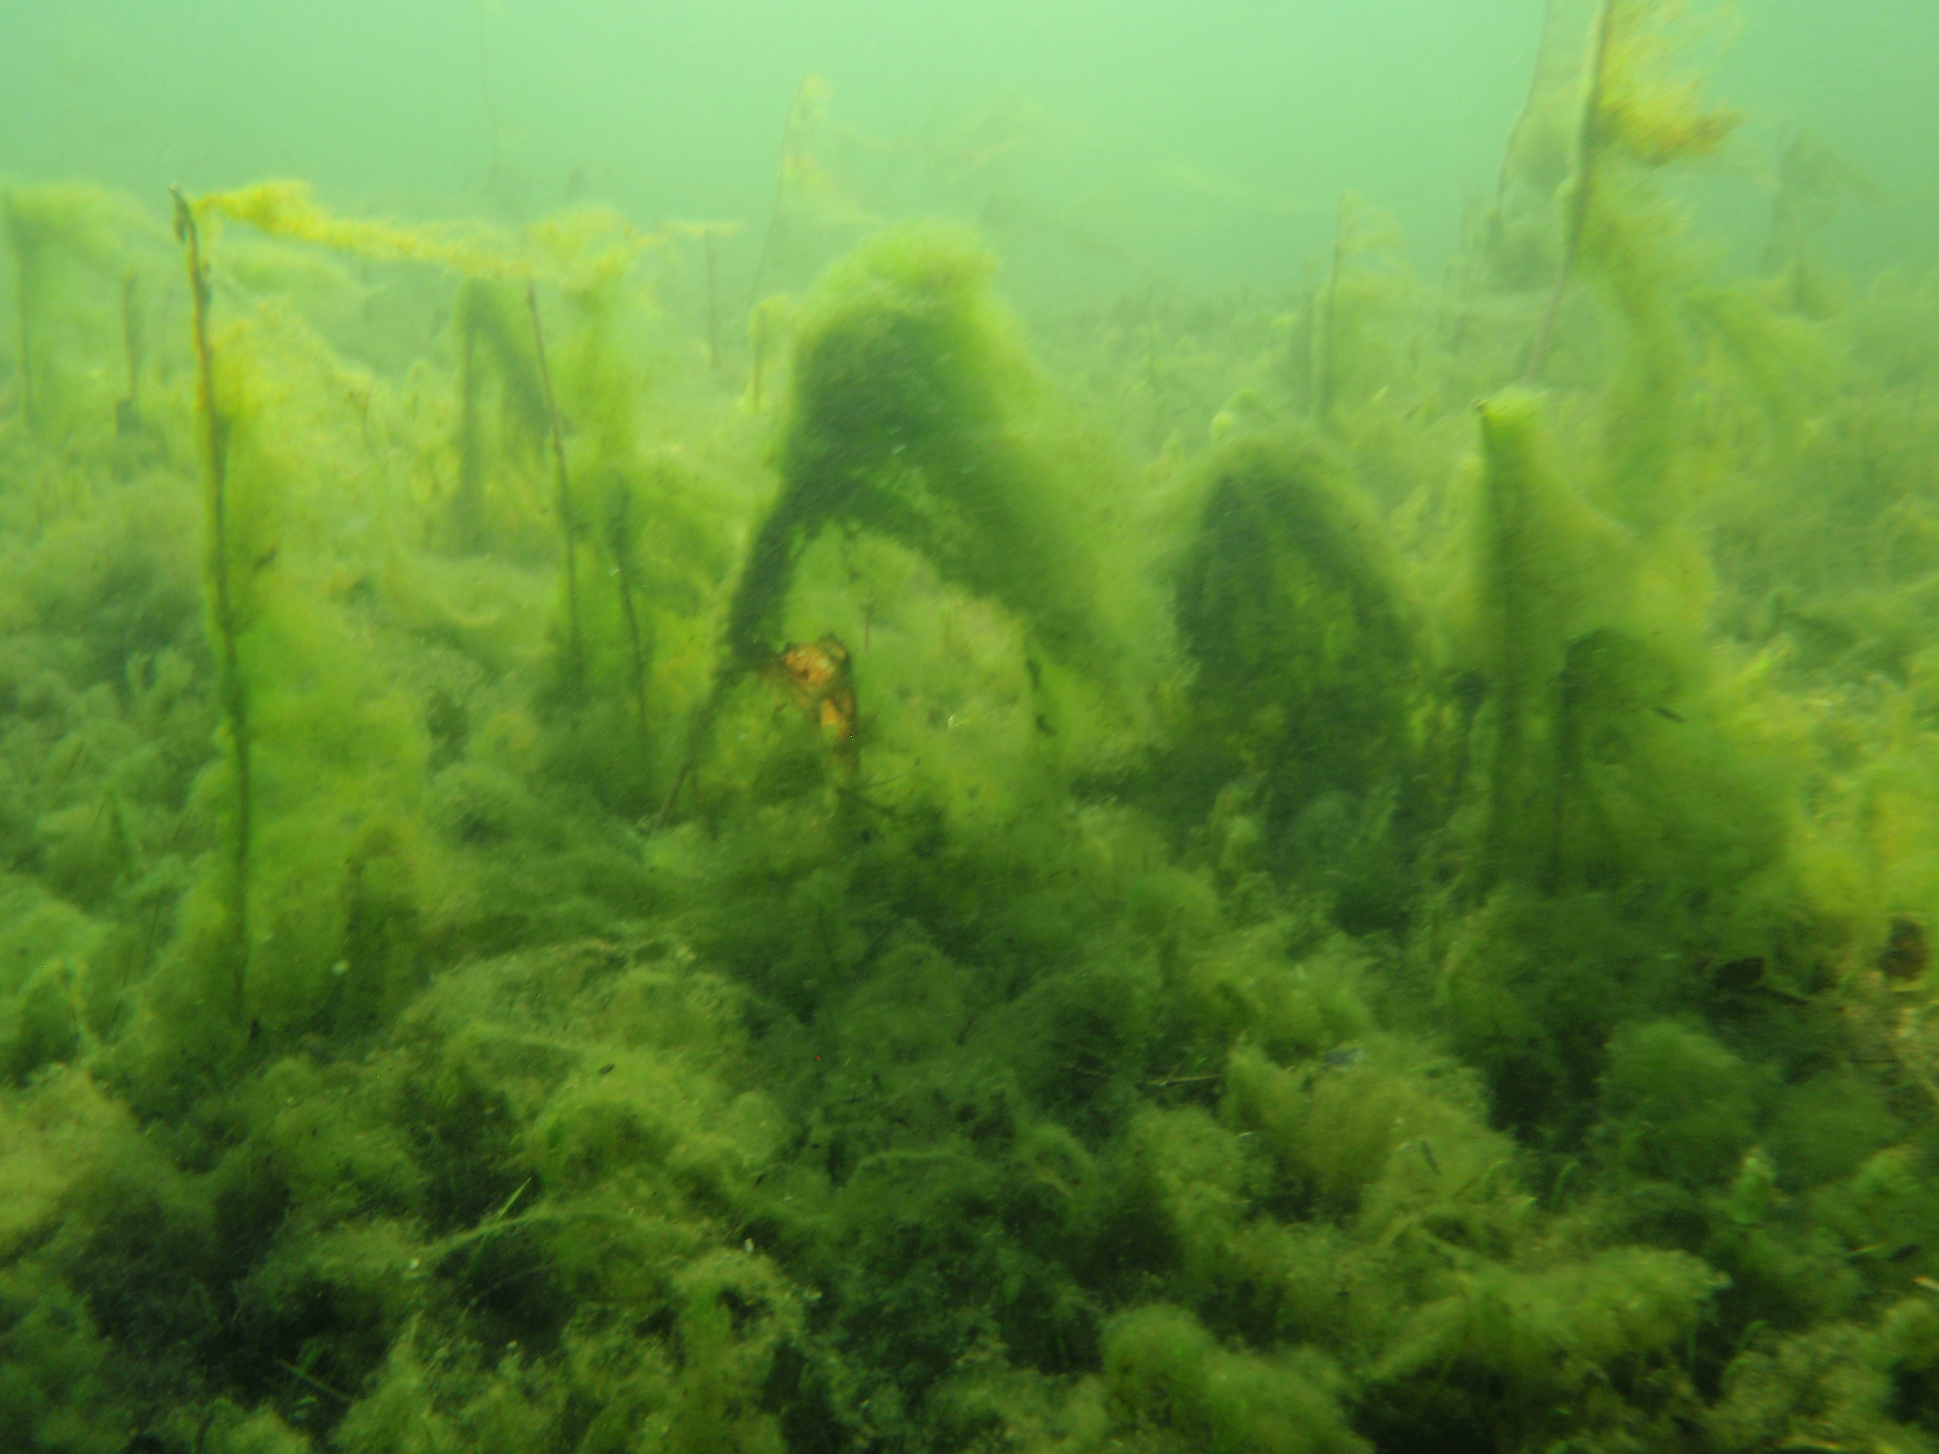
Algae collected from the algal blooms will be identified and enumerated for bioassessment. The Palmer Pollution Index which rates the organic pollution levels of a water body will be used to evaluate water quality. The main sources of lake pollution are the septic seepage (organic), storm water runoff, fertilizers, pesticides and road salt.
All of us have seen the resulting decline in water quality from the scum which coats our boats to the muck that clings to our docks to the blooms that carpet our lake bottoms. The project will also examine the Town of Queensbury septic system inventory to evaluate the state of septic systems on Assembly Point. Residents are encouraged to return the septic system questionnaire to the Town if they have not already done so.
Please consider a tax exempt
donation to the APWQC.
Beverly Pozzi 656-9440
apwqc7@gmail.com
The Assembly Point Water Quality Coalition, Inc. is a 501c3 non-profit corporation committed to improving and restoring water quality and compromised ecosystems in the Lake George Lake Champlain Basin by supporting policies, regulations and practices which preserve and protect waters and watersheds. www.assemblypt.com

Short notes
- The Coalition thanks the following residents for their generous donations: Frances and Calvin Goldscheider, Miriam Brown, Mary Helen O’Keeffe, Sheila Ann Carrell of the William Bernard Trust, Rolf and Luisa Ahlers, Robert and Marg Vanderhyde and Tim and Kathy Bechard.

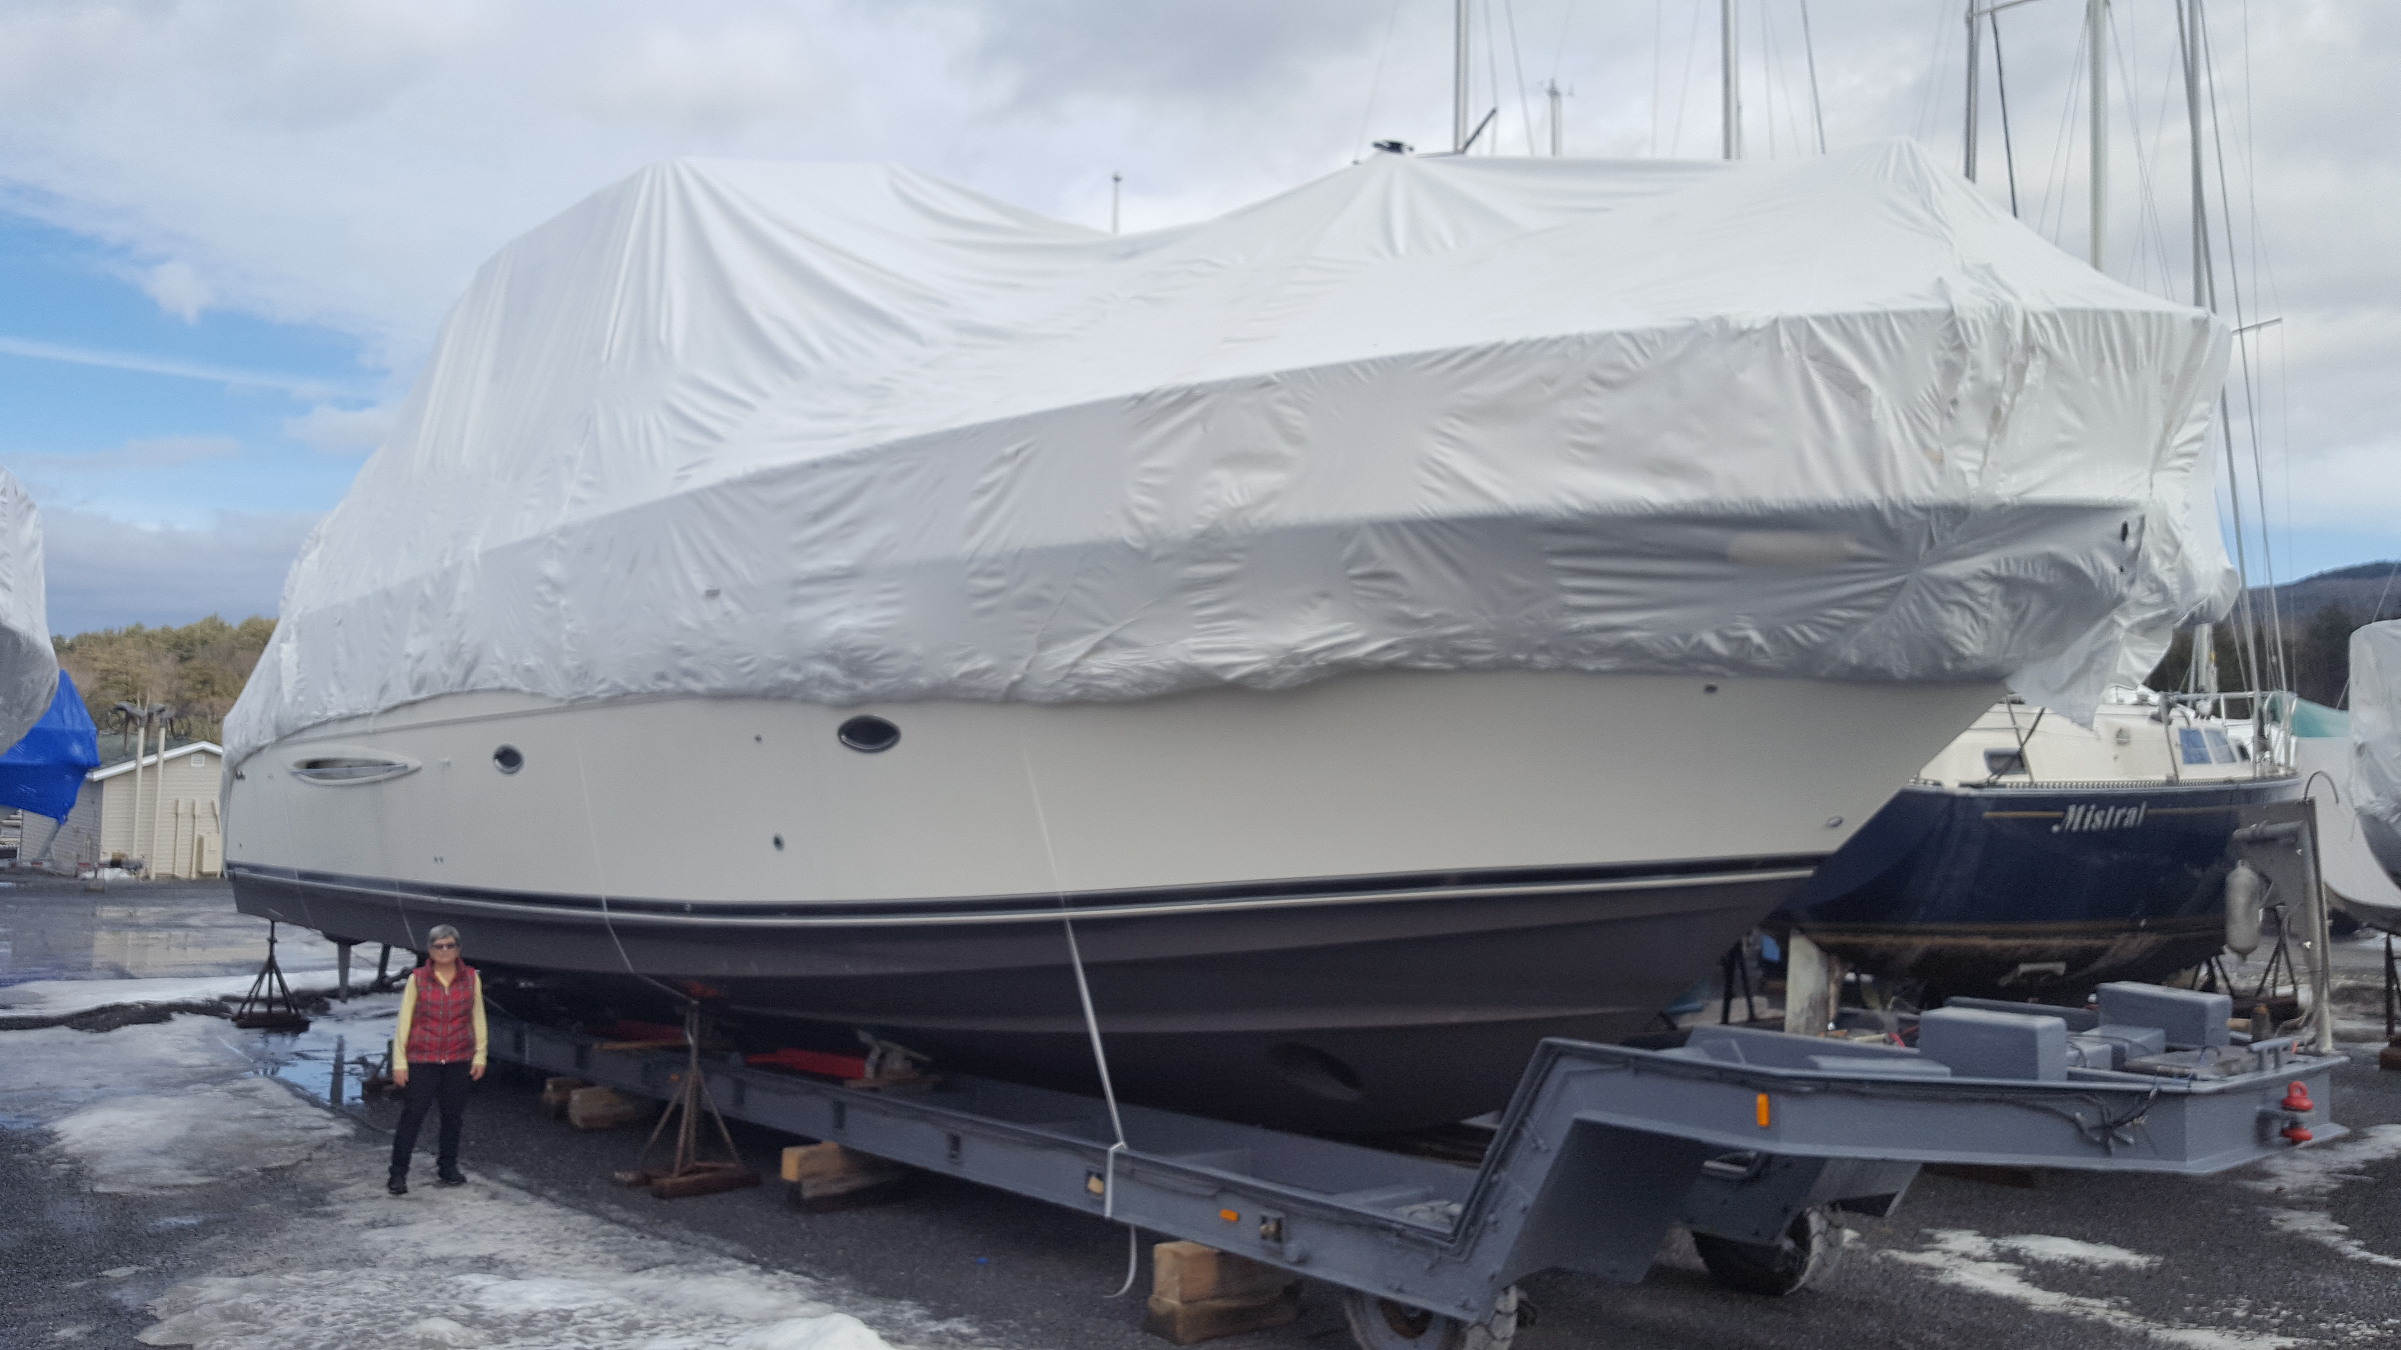
- The Lake George Park Commission tabled the Harris Bay Yacht Club application to reconfigure its docks. The application seeks to replace its wooden floating dock with a larger one made from aluminum and composite materials as well as add a gasoline dock, improve lighting and replace its pilings. The application would accommodate larger boats (see photo) which would add to the boat congestion in the southern basin, erode shorelines and impact wetlands. A petition was circulated with over 300 signatures opposing the application and encouraging the LGPC act on the findings of its recreational boating report on boat congestion in the southern basin.
SAVE THE DATES
The Annual Snorkel Swims are scheduled for the last week of July and first week of August. Please contact Lisa Adamson to join (518) 307-7842
The Assembly Point Social and Annual Meeting will be held at the Cleverdale Country Store on August 16th from 5 to 7 pm. Live Music. All are invited to attend.

